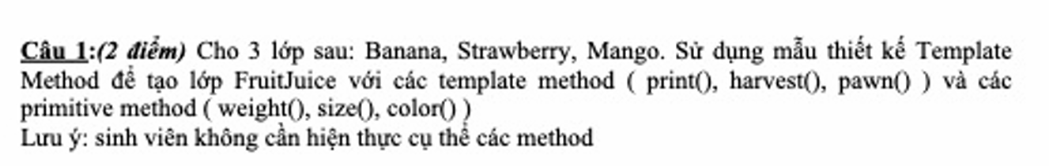
Giải câu 1:
FruitJuice.cs
using System;
namespace NOPKIEMTRA.Project.Models
{
// FruitJuice.cs - Abstract class với Template Method Pattern
public abstract class FruitJuice
{
// Template Method
public void Print()
{
Console.WriteLine($"===== {GetName()} Juice =====");
Console.WriteLine($"Weight: {Weight()}g");
Console.WriteLine($"Size: {Sized()}cm");
Console.WriteLine($"Color: {Color()}");
Console.WriteLine();
}

public void Harvest()
{
Console.WriteLine($"Harvesting {GetName()}...");
}

public void Pawn()
{
Console.WriteLine($"Processing {GetName()} for juice...");
}

// Primitive methods (abstract)
protected abstract int Weight();
protected abstract int Sized();
protected abstract string Color();
protected abstract string GetName();
}

// Banana.cs
public class Banana : FruitJuice
{
protected override int Weight() => 120;
protected override int Sized() => 20;
protected override string Color() => "Yellow";
protected override string GetName() => "Banana";
}

// Strawberry.cs
public class Strawberry : FruitJuice
{
protected override int Weight() => 15;
protected override int Sized() => 3;
protected override string Color() => "Red";
protected override string GetName() => "Strawberry";
}

// Mango.cs
public class Mango : FruitJuice
{
protected override int Weight() => 300;
protected override int Sized() => 15;
protected override string Color() => "Orange";
protected override string GetName() => "Mango";
}

// Program.cs - Class với hàm output
public class Program
{
public static void Output()
{
FruitJuice banana = new Banana();
FruitJuice strawberry = new Strawberry();
FruitJuice mango = new Mango();

banana.Harvest();
banana.Pawn();
banana.Print();

strawberry.Harvest();
strawberry.Pawn();
strawberry.Print();

mango.Harvest();
mango.Pawn();
mango.Print();
}

static void Main()
{
Output();
}
}
}

Program.cs
FruitJuice bananaJuice = new Banana();
FruitJuice strawberryJuice = new Strawberry();
FruitJuice mangoJuice = new Mango();
bananaJuice.Print();
strawberryJuice.Print();
mangoJuice.Print();

Kết quả:
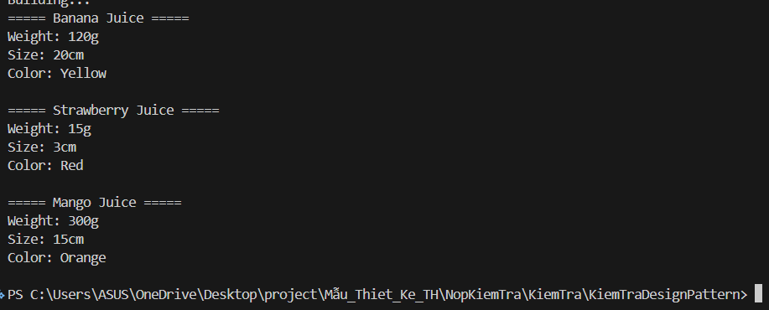

Bài 2
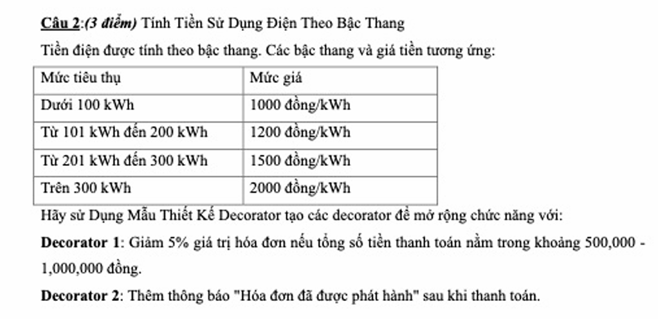

Giải câu 2:
IElectricBill.cs
// IElectricBill.cs - Component Interface
using System;

namespace NOPKIEMTRA.Project.Models
{
public interface IElectricBill
{
double CalculateBill();
void Display();
}

// ConcreteComponent - Tính tiền điện theo bậc thang
public class ElectricBillCalculator : IElectricBill
{
private double _kwhUsed;

public ElectricBillCalculator(double kwhUsed)
{
_kwhUsed = kwhUsed;
}

public double CalculateBill()
{
double totalBill = 0;

if (_kwhUsed <= 100)
{
totalBill = _kwhUsed * 1000;
}
else if (_kwhUsed <= 200)
{
totalBill = 100 * 1000 + (_kwhUsed - 100) * 1200;
}
else if (_kwhUsed <= 300)
{
totalBill = 100 * 1000 + 100 * 1200 + (_kwhUsed - 200) * 1500;
}
else
{
totalBill = 100 * 1000 + 100 * 1200 + 100 * 1500 + (_kwhUsed - 300) * 2000;
}

return totalBill;
}

public void Display()
{
Console.WriteLine($"kWh sử dụng: {_kwhUsed}");
Console.WriteLine($"Tiền điện: {CalculateBill():N0} đồng");
}
}

// Decorator Base Class
public abstract class ElectricBillDecorator : IElectricBill
{
protected IElectricBill _bill;

public ElectricBillDecorator(IElectricBill bill)
{
_bill = bill;
}

public virtual double CalculateBill()
{
return _bill.CalculateBill();
}

public virtual void Display()
{
_bill.Display();
}
}

// Decorator 1 - Giảm 5% nếu tổng tiền trong khoảng 500,000 - 1,000,000 đồng
public class DiscountDecorator : ElectricBillDecorator
{
public DiscountDecorator(IElectricBill bill) : base(bill) { }

public override double CalculateBill()
{
double bill = _bill.CalculateBill();

if (bill >= 500000 && bill <= 1000000)
{
bill = bill * 0.95; // Giảm 5%
Console.WriteLine($"Áp dụng giảm giá 5%: {bill:N0} đồng");
}

return bill;
}
}

// Decorator 2 - Thêm thông báo hóa đơn đã được phát hành
public class IssuedNotificationDecorator : ElectricBillDecorator
{
public IssuedNotificationDecorator(IElectricBill bill) : base(bill) { }

public override void Display()
{
_bill.Display();
Console.WriteLine("Hóa đơn đã được phát hành");
}
}
}

Program.cs
IElectricBill bill = new ElectricBillCalculator(250); // 250 kWh
bill = new DiscountDecorator(bill);
bill = new IssuedNotificationDecorator(bill);

Console.WriteLine("===== Hóa Đơn Điện =====");
bill.Display();
Console.WriteLine($"Tiền cuối cùng: {bill.CalculateBill():N0} đồng\n");

Kết quả
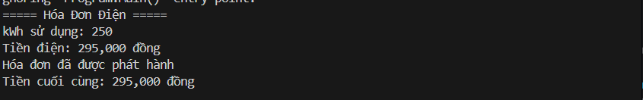

Bài 3:
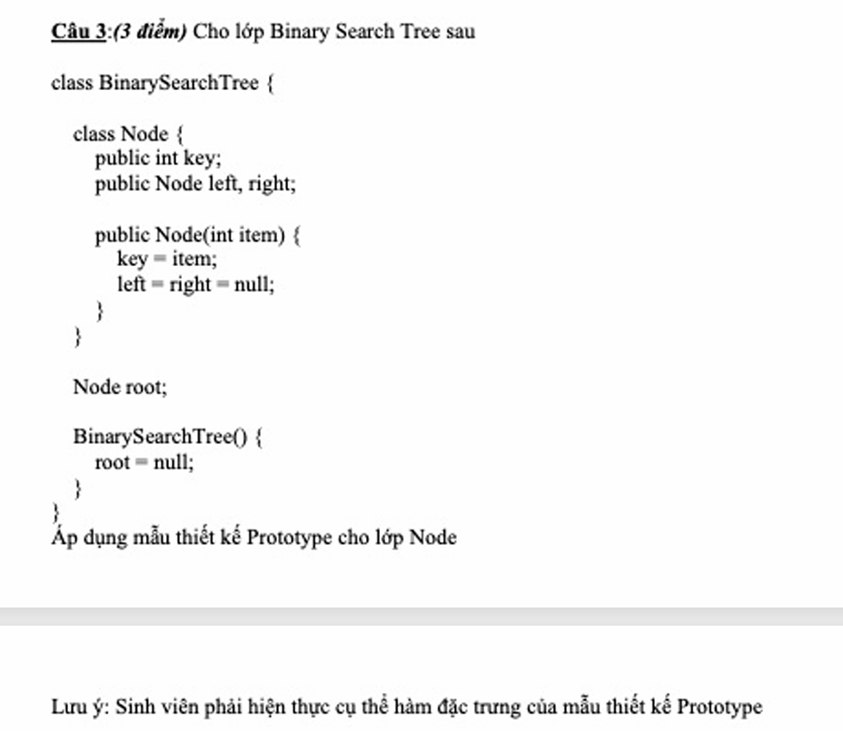
Giải bài 3:
BinarySearchTree.cs
// BinarySearchTree.cs - Prototype Pattern
using System;

namespace NOPKIEMTRA.Project.Models
{
public class BinarySearchTree
{
// Inner class Node với Prototype Pattern
public class Node : ICloneable
{
public int key;
public Node left, right;

public Node(int item)
{
key = item;
left = right = null;
}

// Prototype Pattern - Clone node
public object Clone()
{
Node newNode = new Node(this.key);
newNode.left = this.left != null ? (Node)this.left.Clone() : null;
newNode.right = this.right != null ? (Node)this.right.Clone() : null;
return newNode;
}
}

private Node root;

public BinarySearchTree()
{
root = null;
}

// Insert node vào tree
public void Insert(int item)
{
root = InsertRec(root, item);
}

private Node InsertRec(Node node, int key)
{
if (node == null)
{
return new Node(key);
}

if (key < node.key)
{
node.left = InsertRec(node.left, key);
}
else if (key > node.key)
{
node.right = InsertRec(node.right, key);
}

return node;
}

// Search node
public bool Search(int key)
{
return SearchRec(root, key);
}

private bool SearchRec(Node node, int key)
{
if (node == null)
{
return false;
}

if (key == node.key)
{
return true;
}
else if (key < node.key)
{
return SearchRec(node.left, key);
}
else
{
return SearchRec(node.right, key);
}
}

// Inorder traversal (trái - gốc - phải)
public void Inorder()
{
Console.Write("Inorder: ");
InorderRec(root);
Console.WriteLine();
}

private void InorderRec(Node node)
{
if (node != null)
{
InorderRec(node.left);
Console.Write(node.key + " ");
InorderRec(node.right);
}
}

// Clone toàn bộ tree
public BinarySearchTree CloneTree()
{
BinarySearchTree newTree = new BinarySearchTree();
newTree.root = root != null ? (Node)root.Clone() : null;
return newTree;
}

// Display tree structure
public void Display()
{
Console.WriteLine("Tree structure:");
DisplayRec(root, "", true);
}

private void DisplayRec(Node node, string indent, bool last)
{
if (node != null)
{
Console.Write(indent);
if (last)
{
Console.Write("└─");
indent += " ";
}
else
{
Console.Write("├─");
indent += "│ ";
}
Console.WriteLine(node.key);

DisplayRec(node.left, indent, false);
DisplayRec(node.right, indent, true);
}
}
}
}

Program.cs
Console.WriteLine("\n===== Bài 3: Binary Search Tree - Prototype Pattern =====");
BinarySearchTree bst = new BinarySearchTree();

// Insert values
int[] values = { 50, 30, 70, 20, 40, 60, 80 };
foreach (int val in values)
{
bst.Insert(val);
}

Console.WriteLine("Tree gốc:");
bst.Display();
bst.Inorder();

// Sử dụng Prototype Pattern - Clone tree
BinarySearchTree clonedBst = bst.CloneTree();
Console.WriteLine("\nTree sau khi clone:");
clonedBst.Display();
clonedBst.Inorder();

// Search
Console.WriteLine("\nSearch 40: " + (bst.Search(40) ? "Tìm thấy" : "Không tìm thấy"));
Console.WriteLine("Search 100: " + (bst.Search(100) ? "Tìm thấy" : "Không tìm thấy"));

Kết quả chạy

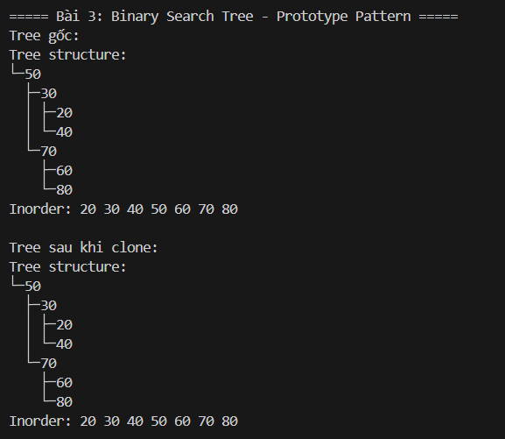

Bài 4:
Worker.cs
// Worker.cs - Interface
using System;
using System.Collections.Generic;

namespace NOPKIEMTRA.Project.Models
{
public interface IWorker
{
void ShowDetails();
long GetSalary();
}

// Constructor : Worker
public class Constructor : IWorker
{
private long id;
private string name;
private int workingDay;
private int salaryPerDay;
private double baseSalary;

public Constructor(long id, string name, int workingDay, int salaryPerDay, double baseSalary)
{
this.id = id;
this.name = name;
this.workingDay = workingDay;
this.salaryPerDay = salaryPerDay;
this.baseSalary = baseSalary;
}

public void ShowDetails()
{
Console.WriteLine($"Constructor: ID={id}, Name={name}, WorkingDay={workingDay}, SalaryPerDay={salaryPerDay}, BaseSalary={baseSalary:N0}");
}

public long GetSalary()
{
return (long)(baseSalary + workingDay * salaryPerDay);
}
}

// Manager : Worker
public class Manager : IWorker
{
private long id;
private string name;
private int workingDay;
private int salaryPerDay;

public Manager(long id, string name, int workingDay, int salaryPerDay)
{
this.id = id;
this.name = name;
this.workingDay = workingDay;
this.salaryPerDay = salaryPerDay;
}

public void ShowDetails()
{
Console.WriteLine($"Manager: ID={id}, Name={name}, WorkingDay={workingDay}, SalaryPerDay={salaryPerDay}");
}

public long GetSalary()
{
return workingDay * salaryPerDay;
}
}

// Director : Worker (Composite)
public class Director : IWorker
{
private long id;
private string name;
private int workingDay;
private int salaryPerDay;
private double bonus;
private List<IWorker> subordinates; // Danh sách nhân viên quản lý

public Director(long id, string name, int workingDay, int salaryPerDay, double bonus)
{
this.id = id;
this.name = name;
this.workingDay = workingDay;
this.salaryPerDay = salaryPerDay;
this.bonus = bonus;
this.subordinates = new List<IWorker>();
}

public void AddSubordinate(IWorker worker)
{
subordinates.Add(worker);
}

public void RemoveSubordinate(IWorker worker)
{
subordinates.Remove(worker);
}

public void ShowDetails()
{
Console.WriteLine($"Director: ID={id}, Name={name}, WorkingDay={workingDay}, SalaryPerDay={salaryPerDay}, Bonus={(bonus * 100):F1}%");
Console.WriteLine("Subordinates:");
foreach (var worker in subordinates)
{
Console.Write(" ");
worker.ShowDetails();
}
}

public long GetSalary()
{
return (long)(workingDay * salaryPerDay * (1 + bonus));
}

// Tính tổng lương của tất cả nhân viên trong công ty
public long GetTotalSalary()
{
long totalSalary = GetSalary(); // Lương director

foreach (var worker in subordinates)
{
if (worker is Director director)
{
totalSalary += director.GetTotalSalary(); // Recursive
}
else
{
totalSalary += worker.GetSalary();
}
}

return totalSalary;
}

public List<IWorker> GetSubordinates()
{
return subordinates;
}
}

// Adapter - Tính lương theo cách thức của công ty
public class SalaryAdapter
{
public static void DisplayCompanySalary(Director director)
{
Console.WriteLine("\n===== Tính Lương Công Ty =====");
director.ShowDetails();
Console.WriteLine($"\nTổng lương công ty: {director.GetTotalSalary():N0} đồng");
}
}
}

Program.cs
Console.WriteLine("\n===== Bài 4: Composite Pattern - Quản Lý Nhân Viên =====");

// Tạo công ty với cấu trúc phân cấp
Director directorMain = new Director(1, "Nguyễn Văn A", 22, 500000, 0.1);

// Manager cấp 1
Manager manager1 = new Manager(2, "Trần Thị B", 22, 300000);
Manager manager2 = new Manager(3, "Lê Văn C", 22, 300000);

// Constructor
Constructor constructor1 = new Constructor(4, "Phạm Minh D", 22, 200000, 5000000);
Constructor constructor2 = new Constructor(5, "Hoàng Thanh E", 22, 200000, 5000000);
Constructor constructor3 = new Constructor(6, "Võ Kim F", 22, 200000, 5000000);

// Sub-director
Director subDirector = new Director(7, "Đỗ Nhân G", 22, 400000, 0.05);

// Xây dựng cấu trúc
directorMain.AddSubordinate(manager1);
directorMain.AddSubordinate(manager2);
directorMain.AddSubordinate(subDirector);

manager1.ShowDetails();
Console.WriteLine($"Lương Manager1: {manager1.GetSalary():N0} đồng\n");

manager2.ShowDetails();
Console.WriteLine($"Lương Manager2: {manager2.GetSalary():N0} đồng\n");

constructor1.ShowDetails();
Console.WriteLine($"Lương Constructor1: {constructor1.GetSalary():N0} đồng\n");

// Sub-director quản lý constructor
subDirector.AddSubordinate(constructor1);
subDirector.AddSubordinate(constructor2);
subDirector.AddSubordinate(constructor3);

Console.WriteLine($"Lương SubDirector: {subDirector.GetSalary():N0} đồng\n");

// Sử dụng Adapter để hiển thị lương công ty
SalaryAdapter.DisplayCompanySalary(directorMain);

Kết quả chạy

